Library Workflows

1. Selling Scholarships to Libraries
2. As new student arrive we assign those open scholarships to students

## How Open Ended Works

An open ended product allows an admin or the student to select from a list of FIXED products at the time the open ended purchase is being assigned.

## Creating New FIXED Products

* Create a FIXED Product that points directly to the training plan
* Add this to all categories that you need it available in.

## Creating new OPEN-ENDED Products

* Open ended products
* Open Ended mappings allow you to select from a list of products when the product is assigned to a student.
* The list is based on the products assigned to the category that the mapping points to.

## Onboarding a New Library

* Creating the Library Store
* Create a library group in the NexPort Part 1 and Part 2 Organizations
* BRANDING: Update the messages and pages for the store (like the welcome messages, etc.)
* Create product mappings for the Part 1 / Part 2 Training plans available to the new store
  + This new mapping will determine the group memberships new students receive when a scholarship is assigned to them.
  + Create a mapping for the **Fixed Products**
  + **DO NOT Create an additional** mapping for the Open Ended Products. They should fall back to the default.
* Determine if the existing “Open Ended” Categories will work for selecting a product at the time it’s assigned to a student
  + If none of the existing categories work you’ll have to create a new one.
* “Sell” them the initial set of scholarships (products) See Adding more scholarships below.

## Adding more Scholarships to a Library

* Libraries should ONLY be “Sold” Open Ended products
* For california most

## Onboarding a new Student

* Find the Library in the BY GROUP menu item

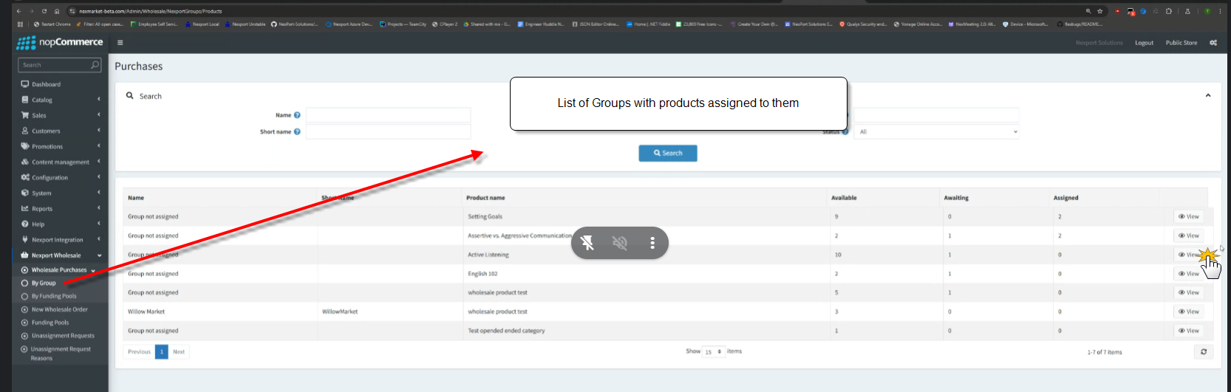

* Hit view
* Use assign option to assign the existing scholarship  
  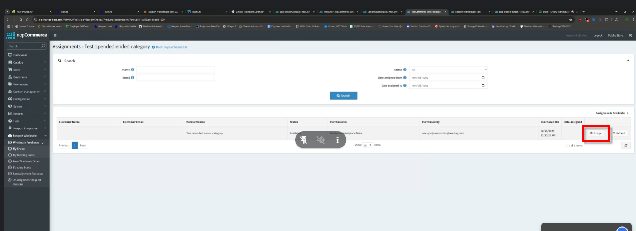
* Walk through the assign a product wizard:  
  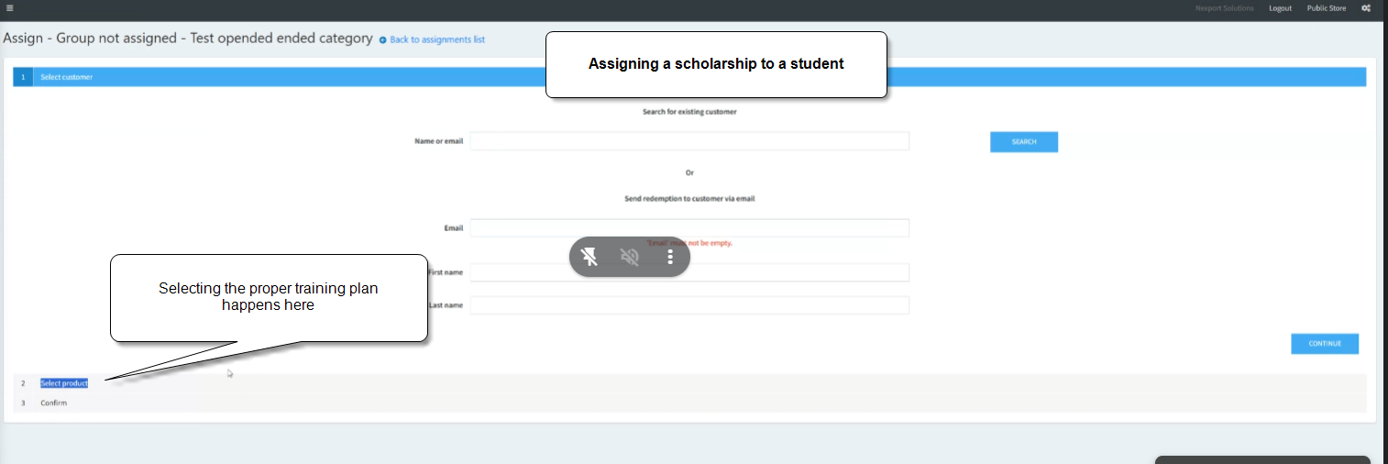
* Select the product to assign from the list  
  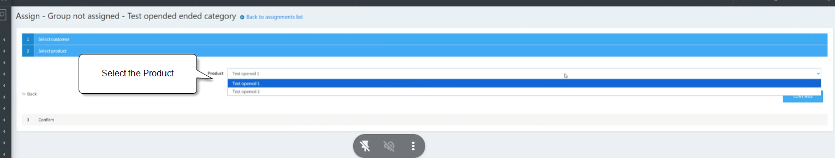
* **Select the Store the purchase is being made through**
* **Select the “library” purchasing group that will own this scholarship**
* **Select any group memberships OR DEPEND ON THE MAPPING**
  + **Need to test that the mapping for memberships gets picked up here??**
* Confirm  
  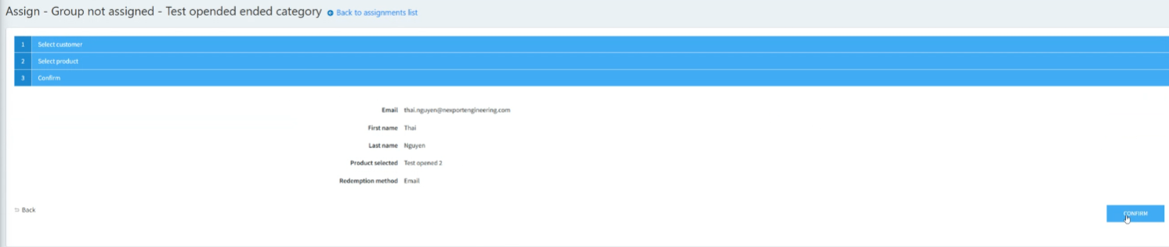

## Offboarding a Library Student

* Unassign the scholarship product.

## Extending a Student with a new Scholarship

Student receive an extension (like 18 months) and it should be tracked as a separate scholarship in the same program and enrollment.

* Just extends to expiration on the existing enrollment
* Purchasing Group remains the same
* The new invoice item is associated with the enrollments
* The old invoice item is still associated with the enrollment

## Removing scholarships from a Library

* Use the refund??
* Can only be done on unassigned seats

## Retiring a Product

* Remove the PRODUCT from the Part 2 Category